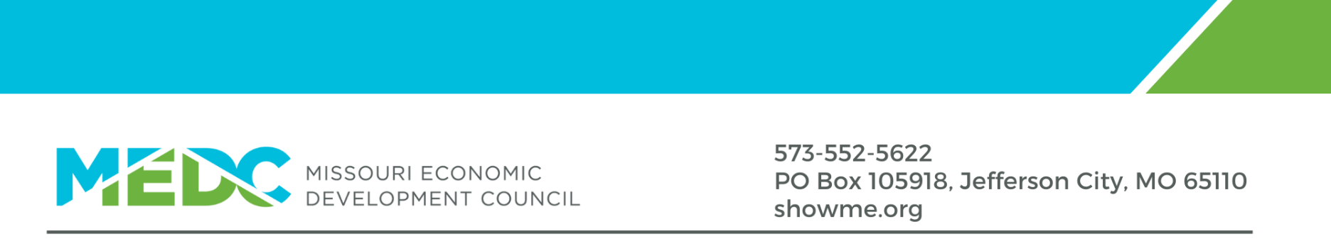
MEDC Executive Director
Job Description
Introduction
Since 1979, the Missouri Economic Development Council (MEDC) has been the authoritative voice on economic development and related issues and is the only membership association representing economic development professionals in the state of Missouri.
MEDC is a membership-based professional association that derives revenue from dues, conferences, and sponsorships. The membership base consistently includes more than 400 members, primarily including local and regional economic developers, utility providers, and other related professionals. MEDC provides services to its members, including professional development through conferences, advocacy and legislative policy work, and the Missouri Certified Economic Developer program.
MEDC is led by a volunteer Board of Directors. The organization’s officers include a President, President-Elect, Treasurer, Secretary, and Past-President, who comprise the Executive Committee.
The Opportunity
MEDC is seeking its next Executive Director. Prior economic development experience is not required, although familiarity with the economic development field is preferred. The ideal candidate will bring a demonstrated record of effective leadership in a membership-based, nonprofit, or similar organization, including experience leading strategic planning initiatives and managing organizational budgets. Strong candidates will have experience working with volunteer leaders, supporting organizational programs and activities, and developing revenue opportunities that advance the organization’s mission.
The Board of Directors seeks a self-directed leader who will take ownership of MEDC’s day-to-day operations, lead implementation of the organization’s newly established strategic plan, strengthen member value, and help deliver measurable results for the association.
As the organization’s sole employee, the Executive Director must be comfortable managing competing priorities, exercising sound judgment, and independently coordinating day-to-day operations while working closely with the Board, volunteers, and contracted partners.
This is a remote-based position with required attendance at periodic in-person meetings and events throughout Missouri. The successful candidate may reside anywhere in Missouri with the ability to regularly travel to Jefferson City during annual legislative sessions.
Salary Range: $85,000 - $95,000, dependent on qualifications
Benefits: Package that includes health, paid time off, and a 401(k)-retirement plan.
Start Date: Late October 2026/Early to Mid-November 2026
Key Roles & Responsibilities
- Member Services & Communications
  - Recruit new members and retain existing members to support organizational growth and revenue.
  - Develop, organize, and distribute communications through a variety of channels.
- Professional Development & Events
  - Support the MoCED certification program by working with the existing contract vendor that provides courses and exams.
  - Manage the contracted event management company supporting MEDC’s conferences and events.
  - Lead, organize, and execute several conferences and events with input from volunteers.
- Public Policy
  - Support the organization’s public policy agenda by working with volunteer leadership and MEDC’s long-standing contract lobbyist.
- Business Operations
  - Manage day-to-day operations in a single-employee office environment, balancing administrative, financial, member service, event, and strategic priorities.
  - Provide budget and financial oversight; organize Board and committee meetings; and manage routine administrative and business activities, including website management and social media.
  - Lead implementation of MEDC’s newly established strategic plan in coordination with the Board of Directors and volunteer leadership.
  - Undertake special projects at the Board’s direction.
- Finance & Accounting
  - Manage MEDC’s financial affairs in conjunction with the Board, Treasurer, and third-party vendors.
  - Execute strategies to ensure the continued profitability and sustainability of MEDC.
  - Maintain a membership database and billing schedule, organizational finances, and bookkeeping.
Reporting Relationships
- The Executive Director will report directly to the President of the Board of Directors.
- The President of the Board of Directors acts in cooperation with the Executive Committee and the Board of Directors.
Desired Attributes & Knowledge
- Have the proven ability to guide and execute an organization’s vision, strategy, and strategic plan
- Have a strong financial and administrative background
- Be highly organized, self-directed, and able to work independently
- Demonstrate high attention to detail in planning, communication, financial oversight, and execution
- Demonstrate excellent time management, prioritization, and follow-through in a single-employee office environment
- Have strong computer skills including Microsoft applications and other online platforms
- Be an extremely effective communicator and listener
- Be a passionate advocate for MEDC
- Be able to travel on occasion, most extensively during annual legislative sessions
Desired Experience
- Financial P&L responsibility and budgeting experience at the organizational, firm, or divisional level
- Experience leading implementation of an organizational strategic plan or major strategic initiative
- Prior experience managing third-party professional service providers
- Experience on, working with, or reporting to a Board of Directors
- Management responsibilities in a membership-based organization
- Prior experience directing the activities of a professional or trade association, public-private partnership, or similar organization is preferred
Required Qualifications
- Bachelor’s degree from an accredited university
- Five or more years of related experience
- Must be eligible to register as a lobbyist with the Missouri Ethics Commission
Application & Interview Process
- Application
  - Open: August 17 – September 15, 2026
  - Application review is ongoing until the role is filled.
  - Interested persons should submit their credentials and contact information to executive.director@showme.org
  - Please direct any questions regarding this posting to: Jill Hancock at executive.director@showme.org
- Interviews
  - Initial interview timeline: Beginning in late September/early-mid October 2026
  - Format:
    - Initial interviews will be conducted virtually by MEDC’s search committee.
    - If selected to advance, additional interviews may be conducted in person by MEDC’s search committee and/or the Executive Committee.

---
The Missouri Economic Development Council provides equal employment opportunities to all employees and applicants for employment and prohibits discrimination and harassment of any type without regard to race, color, religion, age, sex, national origin, disability status, genetics, protected veteran status, sexual orientation, gender identity or expression, or any other characteristic protected by federal, state, or local laws.
This policy applies to all terms and conditions of employment, including recruiting, hiring, placement, promotion, termination, layoff, recall, transfer, leaves of absence, compensation, and training.

